**How to play AVMICO**

AVMICO (short for “Autonomous Vehicle Mining Corporation” – I never have had much of a skill in naming things ….) is a cross between a mining game, Railroad Tycoon and Lemmings.

Sorry about sending you here but the instructions simply don’t fit in the Arcade. It’s not a complex game to play once you get the idea, but getting the idea can be a bit tricky (it’s difficult to understand this from the perspective of someone who has never seen it really – I wrote it so I know how it works).

So here’s seven pages of instructions that explains much of it.

It does sound like it’s recorded in a psychotic dentist’s room, sorry ‘bout that.

Short version

The object of the game is to make money (yay ! no killing things !) by mining out an area of ground. The ground contains earth, rock, coal, silver, gold and diamonds. There is a granite area limiting how far you can go.

You get money by extracting them from the rock, and bringing them to the surface (*the Mining game bit*).

You extract them from the rock, and bring them to the surface, using a collection of wagons each of which has its own function, purpose and behaviour. You do not control these wagons, you tell them to go somewhere and do it, and they do to the best of their ability (*the Lemmings bit*)

You have to maintain an area of shafts and networks and fast rails to maximise your production. You can get more wagons so you can do more at the same time. There is a very simple economy (*the Railroad Tycoon bit*)

It’s more cerebral than shooting I’m afraid. I really didn’t want to do obvious things like Platform games underground or the like. So I came up with this.

The source is available from <https://github.com/paulscottrobson/Underground> if you want to see how it works.

Long version

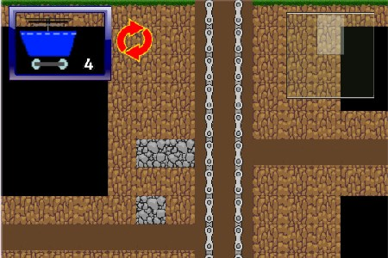

You spend most of your time looking at this. It’s an area of the mine – you can see the scanner on the right, which shows you the bit of the mine you are looking at (and will show you the wagons when they are in the mine).

You can move this by dragging it, clicking on the scanner, the usual sorts of things. If you touch at the very top it goes “home” to this position, the mine entry.

The area itself shows the bits of the mine. The black bits are unexplored – the representation of coal, earth, rock, granite, silver, gold and diamonds are hopefully obvious.

The darker brown bits are your tunnels. Wagons can pass through these easily, all of them. Other places, they have to dig or they simply cannot penetrate – it depends on the wagons, which I will detail later, hopefully, if I remember.

The bits which look like motorbike chains are the lifts, these go up and down, quite quickly because wagons can attach themselves to these and exit and enter fast.

Something not on this picture is track which looks like this C:\Construct2\Underground\Graphics\rail.png these are put in left-right tunnels. These allow you to travel faster – like a subway should (okay, not London Underground but theoretically …..). You only have one shaft and these allow you to build a rapid transit system to mine faster.

**Dispatch**

Most of the game involves telling wagons what to do (the only other thing you can do in the game is buy new wagons).

These are done with these controls.

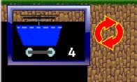

You have wagons to control – initially you have about six or so (depends on my tinkering). The white number tells you how many there are in the queue. This shows you what is at the front of the queue of those wagons – what you might actually have is this.

C:\Construct2\Underground\Graphics\digger.pngC:\Construct2\Underground\Graphics\digger.pngC:\Construct2\Underground\Graphics\collect0.pngC:\Construct2\Underground\Graphics\layer.pngC:\Construct2\Underground\Graphics\driller.pngC:\Users\Paul\AppData\Local\Microsoft\Windows\INetCache\Content.Word\explorer.png

Because it only shows the front of the queue. You can rearrange the queue by sending a wagon to the black, clicking on the double arrow spinny thing – so you do *not* have to send the head of the queue out first.

You dispatch a wagon with two touches or clicks. The first is on the map – anywhere on the map – that you want it to start working. This has to be an area you have already mined, you can’t instruct it to go into a hidden area or earth.

It goes straight there, it doesn’t do anything on the way, and once it is there it starts to do its thing.

When you touch the map somewhere it can go, it will mark it with the marker which looks like this (probably)

C:\Construct2\Underground\Graphics\target.png



For example if you want to start mining the area immediately above the rock six ‘squares’ down and to the left a bit, you have to click where the arrow points in the picture above. It goes there and starts burrowing into the side wall.

Wagons always move away from the centre. This can create dead areas you can’t mine, if you don’t bear this in mind.

Once you have marked your target, another click/tap on the wagon will start it off, and it will go to where your target is, and start working (see wagon description later).

You can then send off another one – you don’t have to wait for the first one to come back.

If they are all out the dispatcher window and control will disappear till one comes back, then you can send it out again.

However, some wagons are “one shot”, you cannot use them more than once.

You can , however, make them return to base by clicking on them while they are on the way to the target. If they are multiple use wagons, you can make them give up early by clicking on them.

**However,once a one-shot wagon has started its work, clicking on it will cause it to vanish from the game.**

**Types of Wagons**

There are, currently, six different types. It actually isn’t difficult to add new ones, the main problem would be fitting them in the shop window ☺

***Explorer Wagons***

C:\Users\Paul\AppData\Local\Microsoft\Windows\INetCache\Content.Word\explorer.png

Explorer wagons are used for exploring. (I’m going to write something like this repeatedly and it sounds really dumb ….). Their main purpose is to snout about and try to find where things are.

They move quite quickly and have some sort of radar system which conveniently allows them to see further than other wagons (e.g. they open up the map quicker).

Their main disadvantage is that they cannot penetrate anything other than normal earth.

***Miner Wagons***

C:\Construct2\Underground\Graphics\digger.png

Miner wagons mine things (I did warn you). They do this fairly well, but they have very limited storage built in (Apple designed them) so they can only bring back Gold, Diamond and Silver (as required to buy Apple products), when they do you get credited with the value of these items. (Note: the difficulty level basically just varies how much money you get for things).

When they mine coal they leave it on the ground to be picked up later.

Miners cannot go through rock. They move at a medium pace but the actual digging is quite slow.

***Collector Wagons***

C:\Construct2\Underground\Graphics\collect0.png

Go on, guess what this does …. If you can’t, I’d advise going back to Galaxians, if you can remember that far back. I’m feeling old ; I went with the missus to see a Bucks Fizz reunion concert which was good fun but it makes you realise how long ago that was (Note for Americans : Bucks Fizz = One Direction but at the time the dinosaurs were on the planet).

Well its purpose, it’s only purpose is to pick up coal and return it to the surface when you get paid for it. It works in tandem with the miner wagon on the previous page to get coal – miner digs it out, collector brings it back.

Its graphic changes depending on what it is carrying (e.g. you can see coal in it).

It is worth going after the precious metals, but you can’t build a whole economy round it.

***Driller Wagons***

C:\Construct2\Underground\Graphics\driller.png

It is too embarrassing, so I will skip the short version.

This is a one-shot wagon. Once you have used it it is *gone*, so you have to make sure you use these in the right areas.

It drills down from wherever it is left to drill, for a maximum depth of six squares. It cannot go through rock or granite vertically. So be careful where you drill.

***Layer Wagons***

C:\Construct2\Underground\Graphics\layer.png

Now, this one isn’t quite so obvious. The layer wagons purpose is to lay the rails (that’s what the thing in the wagon is supposed to be ….), so you can build a transit system to and from different areas of the mine.

This makes things *arrive* at their target four times faster. It does not affect the speed they work at. It is also helpful if you find wagons crossing each other a lot, because this slows them down , also by a factor of four.

**Exploder Wagons**

C:\Construct2\Underground\Graphics\exploder.png

Note the subtle graphic here, if you couldn’t figure it out from the name ….

These too are one-shot wagons, and can also be used in one of two different ways.

Firstly, if they are in a shaft (e.g. you do it on the thing that looks like a chain) they work *downwards*, and can go through anything except the granite (actually the limits of the game ….) – opening up a shaft of about three squares.

Secondly if they are in a horizontal tunnel, they open up a cave and instantly mine all the coal in that area (which needs collecting ……). I actually got this idea from visiting a real former lead and zinc mine in Germany a month or two back. <http://www.bergbaumuseum-mechernich.de/>

**Shopping**

To go to the shops you click on your money total at the bottom, or the coin. If my wife went shopping this easily I’d be much happier. The shop window comes up like this here.

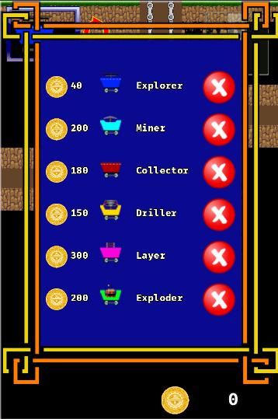It shows you all the wagons, how much they cost, and a button to buy them.

As any Greek readers (and my daughter) will not understand, because you have a total of zero pounds at present you cannot buy anything.

When you have made some money, the button(s) will turn green and you can then buy a new wagon.

It is assumed that you bought it for a reason (and not, say, because it matches your latest hairdo or was in the sale …) so any newly bought wagons are sent to the front of the queue.

**End Game**

There isn’t one. I quite like this game but one criticism which is true is that there isn’t really a target beyond “make lots of money”. I’d also like maybe to add wagons that wear out – at the moment apart from Drillers and Exploders they run for ever, and better wagons. The economy is also quite tricky to get right – if this was a commercial game it would need a lot of testing to get the balance right.

Paul Robson, September 2015.